Czech University of Life Sciences Prague

Faculty of Economics and Management



Internet Technology Client Side
Authors:
BIKAMO TESFALEGN
ISHTIAQ AHMED
UMAIR AFZAL

© 2025 CULS Prague
Introduction
In this project we want to build a responsive website that aims to describe the journey of a new tourist and to guide them throughout the journey. It also helps an explorer to plan their journey from the very beginning till the end. Also, anyone can share their journey experiences as a blog post.

Project Description, Idea, Purpose, and Mission
The TOURPLANNER project is a comprehensive online platform designed to promote tourism and facilitate travel planning specifically focused on the regions of Ethiopia.

Project Idea & Purpose
The core idea is to solve the problem of fragmented travel information by creating a single, organized digital hub that guides users through the process of discovering and booking trips to the Ethiopian highlands.
The main purposes are:
- Discovery: To highlight Ethiopia’s extraordinary natural beauty, diverse landscapes, and rich cultural heritage. This includes showcasing major tourist attractions, traditional Ethiopian dances, local cuisines, the country’s unique geography, and historic sites—many of which are recognized as UNESCO World Heritage sites.
- Utility: Provide functional tools to simplify the planning process (search, itinerary building, pricing).
- Accessibility: Offer different levels of access (Free, Basic, Pro plans) to cater to various traveler needs.

Project Mission
The project's mission is to be the essential planning tool for exploring Ethiopia, empowering users to create customized, unforgettable tours by providing detailed information, advanced features, and a user-friendly platform.
Key Services Offered (Based on the HTML Pages):

index.html (Home)
This is the landing page serving as an introduction to the website.
- Hero Section: Features a background image of the Semien Mountains with a call-to-action button to explore destinations.
- Cultural Dances: A grid section highlighting traditional dances: Wolaita, Eskista (Amhara), and Oromo.
- Cultural Foods: A section showcasing Ethiopian cuisine, specifically Doro wot, Beyayinet, and Tire siga.

attractions.html (Attractions)
This page details specific tourist destinations within the country.
- Hero Section: Features a background image of "Gladababon".
- Top Attractions: A 3-column grid displaying cards for major landmarks, including:
  - Historical Sites: Lalibela rock-hewn churches, Aksum Obelisk, and Fasilides Castles.
  - Natural Wonders: Ajora Falls, Semien Mountains, and the Danakil Depression.
  - Modern/Wild: The GERD Dam and endemic wildlife like the Walia Ibex.

culture.html (Culture)
This page focuses on traditions and festivals.
- Unique Script: Unlike other pages, this file contains an inline script at the top to handle a specific "img-popup" modal, in addition to the standard lightbox at the bottom.
- Hero Section: Features a coffee-themed background.
- Highlights: Displays a grid focusing on the Coffee Ceremony, Timkat (Epiphany) festival, and traditional regional festivals.

About.html (About)
This page provides educational context regarding the nation.
- Information Grid: Sections covering History (ancient civilizations like Aksum), Geography (Highlands and Blue Nile), and People/Languages (120+ ethnic groups).
- Map Integration: Embeds a Google Map via an iframe to visualize the country's location.

tips_contact.html (Travel Tips)
This is the most technically complex page, handling user input and interactions.
- Travel Tips: A list of advice regarding visas, customs, altitude sickness, and guides.
- Contact Form: A detailed form for inquiries including Name, Email, Trip Duration, and Destinations. It uses JavaScript to fetch a list of countries from restcountries.com to populate the "Country" dropdown.
- Hotel Section: Lists three recommended hotels (Skylight, Hilton, Mariot) with "Book Now" links.
- Booking System (Modals):
  - Booking Modal: A popup form that captures user details and dates when a hotel is selected.
  - Payment Modal: A secondary popup that simulates payment processing via Credit Card or PayPal.
  - Scripting: Contains extensive internal JavaScript to handle modal opening/closing, form validation, and simulated payment success messages.

Our developing site's primary functionality:
The primary focus of our developing site lies in the functionality of the page. It involves a comprehensive assessment of both the front-end experience and the overall website layout. Our main challenge lies in effectively choosing and implementing a CSS framework that complements captivating imagery. This strategic combination aims to enhance user accessibility for travelers visiting the page. The content will primarily cover vital information regarding current investment sectors, economic advancements, and other key factors that underscore the region's economic stability and attractiveness.
Within the system, users fall into two distinct categories: guests and administrators. The system's behavior will distinctly cater to these user categories due to their separate roles and access levels. The core emphasis of this front-end project revolves around optimizing the page layout and its structural organization. Eventually, a server-side project will enable the complete set of web page functionalities.

Software Requirements:
Selecting the right software tools is crucial during the development phase. Before settling on specific software, understanding the necessary languages and technologies for the system is vital. The following tools and technologies are set to be utilized in the development of the front-end project:
Visily.ai: For creating our webpage wireframe, Visily.ai was especially effective due to its user-friendly interface and smart design features. It allowed us to quickly map out the structure, layout, and flow of the page, keeping the focus on core wireframing principles without the complexity found in more advanced design tools.
Drawio: Creating the site map for our proposed web page was achieved using the user-friendly and free Drawio tool, simplifying the process of crafting line drawings.
Hypertext Markup Language (HTML): As the fundamental building block of the Web, HTML defines the structure of web content. Various HTML elements are employed to structure our project's web pages. For instance, the HTML element 'iframe' embeds another HTML page within the current page.
Cascading Style Sheets (CSS): CSS is utilized to stylize web pages, defining their appearance and layout across different screens. For example, the CSS code 'color: RED;' can be used to change font color to red.
JavaScript : is a powerful, high-level programming language used to make websites interactive and dynamic. While HTML structures a webpage and CSS styles it, JavaScript brings it to life by enabling real-time actions and behaviors.
Site Map of Web Page:
The site map illustrates a comprehensive list of pages intended for the proposed website. Utilizing Draw.io, we crafted the following site map to offer an initial overview of the web page's structure before delving into the wireframe design. Take a look at the site map for our proposed website below, providing a foundational idea of the web page's layout and navigation.

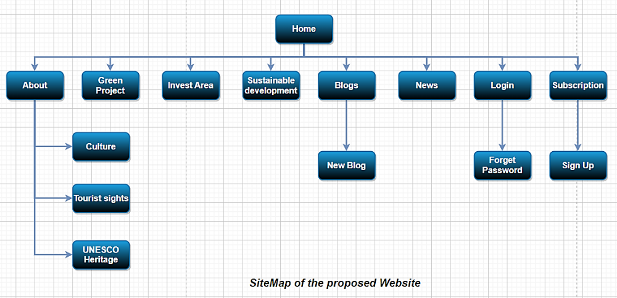
Web navigation Storyboard:
User wants to find out a location of one of the tourist sites in Ethiopia.
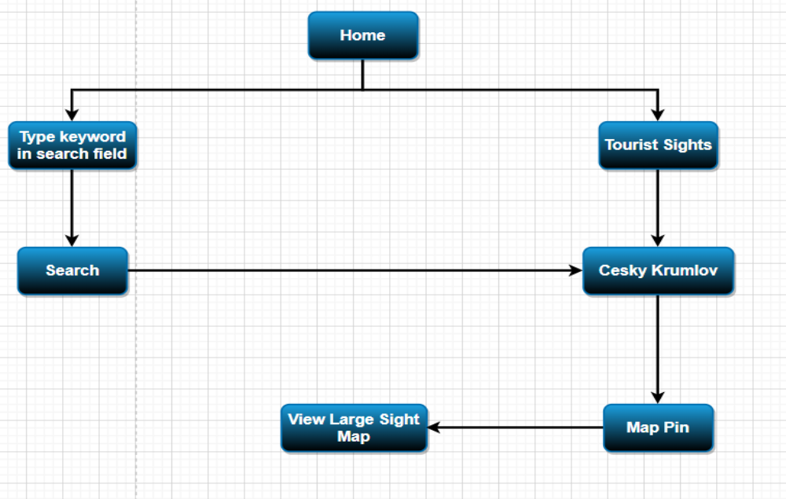
Wireframe:
This section of our project uses wireframe design to obtain a rough idea of structural layouts and proof of concept for our proposed web site. Proposed design of home page in below:

Wireframe of mobile version: is a simple layout that maps out how an app or webpage will look and function on a small phone screen. It shows the arrangement of essential elements—top navigation, icons, content sections, buttons, and menus—focused on clarity, vertical flow, and touch-friendly interactions, without any styling or visuals.
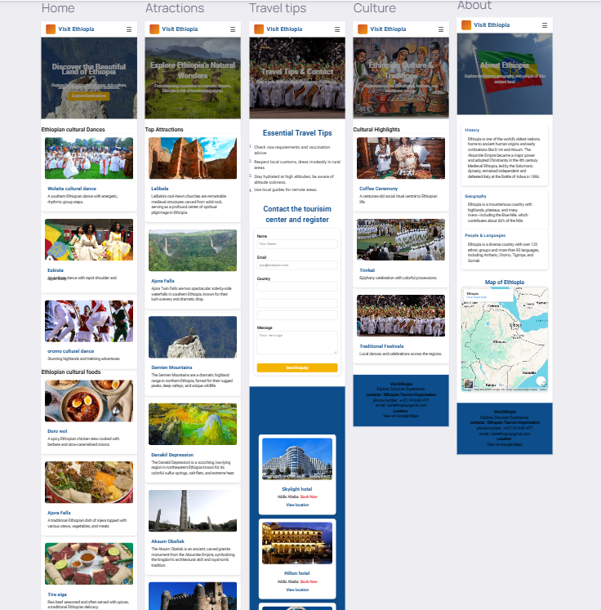

Wire frame of Desktop version : basic, low-fidelity layout that shows how a website or application will be structured on a large desktop screen. It outlines the placement of key elements—header, navigation menu, sidebar, main content area, footer, and interactive components—without detailed design. Its purpose is to plan layout, hierarchy, and user flow for wide-screen usability.
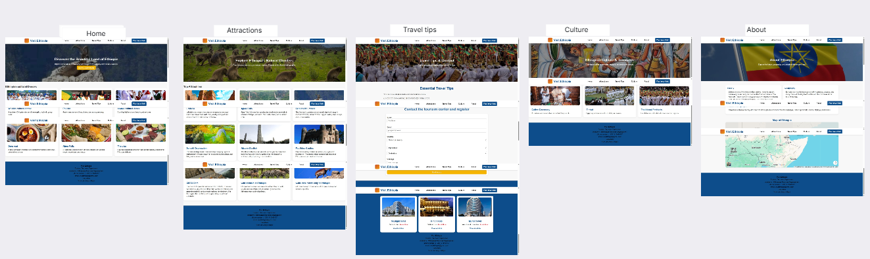

Wireframe of Tablet version: simplified layout showing how an app or website will look and function on a tablet-sized screen. It outlines key elements—navigation, content blocks, buttons, and spacing—without visual design details. The goal is to define structure, user flow, and responsiveness for medium-sized devices.

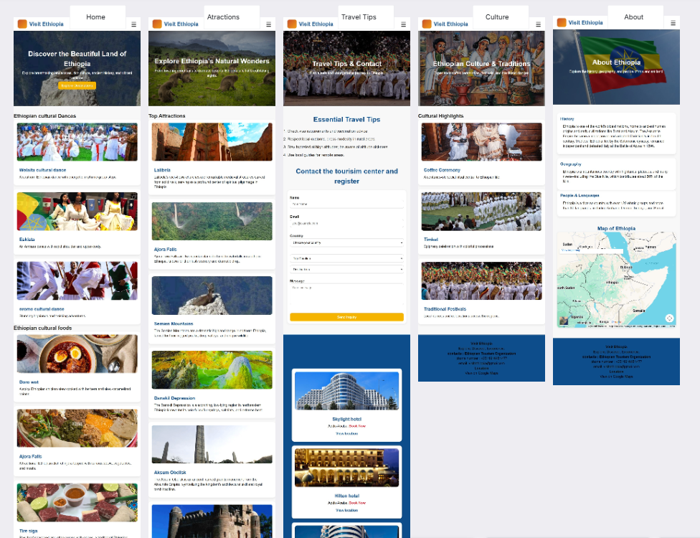

Use case diagram:
We have established two actors (Admin and User) for our project page to develop potential use cases for our suggested processes.
Use case diagram for web page:
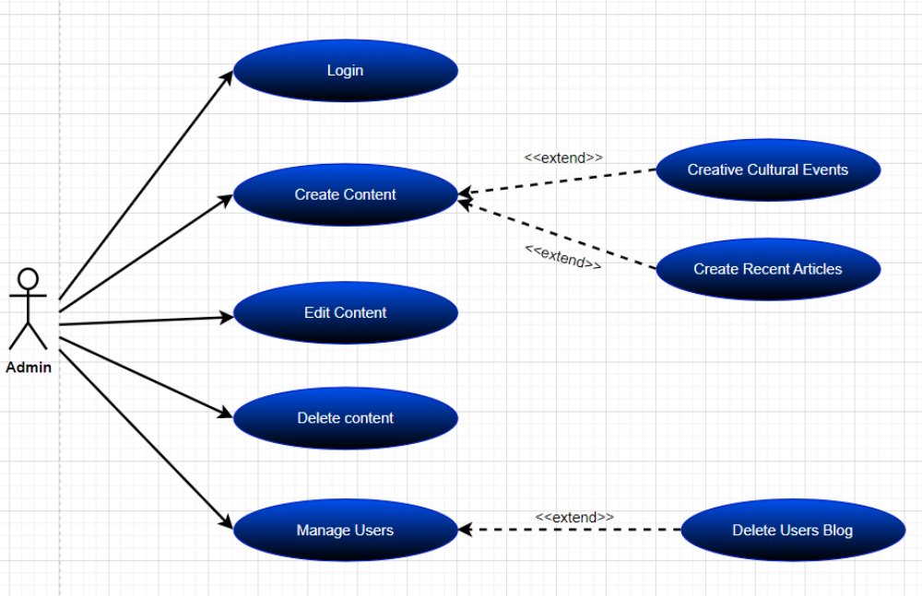

User use case diagram for web page:
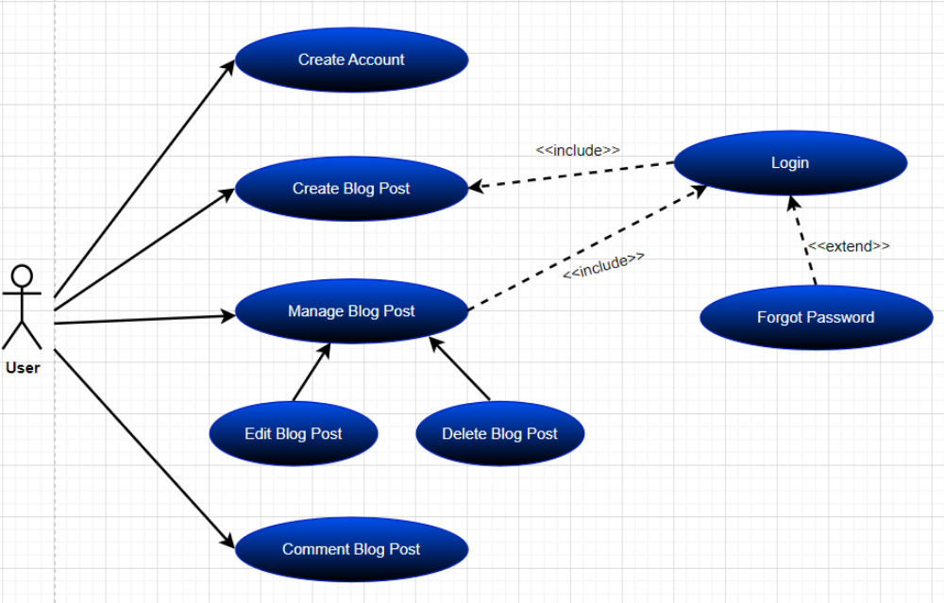

Use Case diagram for Subscribers

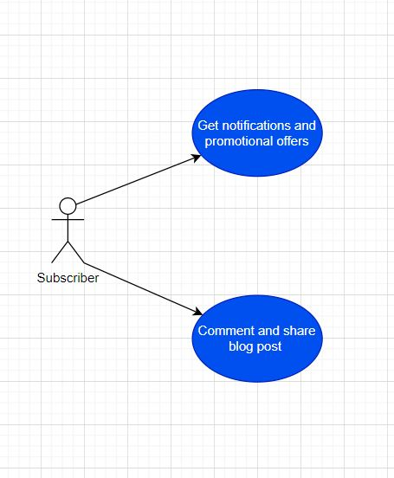
Conclusion:
This phase of our project primarily focuses on establishing a foundational concept that will serve as a communication and brainstorming tool for the upcoming implementation of HTML, CSS, and CSS framework elements in the finalization phase of our project. While practical implementation might warrant occasional revisions to design and layout, the wireframe design sets the general structure that will largely remain intact.
In essence, our primary objective in this section is to vividly showcase the concept guiding the front-end development of our recommended web pages. This serves as a blueprint for the subsequent phases, allowing for a clear understanding of the intended direction before the actual implementation takes place.

